**INDUSTRY INTERNSHIP**

ON

**Study & Implementation EPC (Evolved Packet Core) – IPv4 and IPv6**

**Submitted to**

**Amity School of Engineering and Technology**

**Amity University, Noida**

**In partial fulfillment of the requirements for the degree of**

**B.Tech (Electronics and Communication Engineering)**



**Guided By:                                                                        Submitted By:**

Mr. Lala Bhaskar                                                      Neha Tabassum

ECE Department (A2305116051)

**DEPARTMENT OF ELECTRONICS AND COMMUNICATION ENGINEERING**

**AMITY SCHOOL OF ENGINEERING AND TECHNOLOGY**

**AMITY UNIVERSITY, UTTAR PRADESH**

**Declaration by the student**

I **Neha Tabassum**, student of B.tech (ECE) hereby declare that the project titled **“EPC (Evolved Packet Core) – IPv4 and IPv6”** which is submitted by me to Department of Electronics and Communication, **Amity School of Engineering and Technology**, Amity University Uttar Pradesh, Noida, in partial fulfillment of requirement for the award of the degree of Bachelor of Technology in Electronics and Communication Engineering, has not been previously formed the basis for the award of any degree, diploma or other similar title or recognition.

The Author attests that permission has been obtained for the use of any copy righted material appearing in the Dissertation / Project report other than brief excerpts requiring only proper acknowledgement in scholarly writing and all such use is acknowledged.

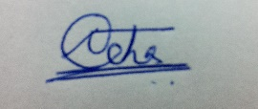

Signature

Neha Tabassum Date:

A2305116051 Noida

Batch: 2016-20

**Certificate by the Guide**

This is to certify that Ms. Neha Tabassum, student of B.Tech in ECE Department has carried out the work presented in the project of the Industry Internship entitle “EPC (Evolved Packet Core) – IPv4 and IPv6” as a part of Four year program of Bachelor of Technology in Electronics and Communication Engineering from Amity School of Engineering and Technology, Amity University, Noida, Uttar Pradesh under my supervision.

Mr. Lala Bhaskar

ECE Department

Amity School of Engineering and Technology,

AUUP

**Acknowledgement**

It is with immense pride that I present the report of my **Summer Training** in **Amity School of Engineering and Technology** which we underwent as a part of the industrial training required in our four year **B.tech programme.**

I would like to express my sincere gratitude to **Reliance Jio** to allow me to undergo industrial training under their guidance.

I would like to extend my gratitude to the training supervisor, **Mr. Kapil Singh** for his support and guidance during the course of the entire training.

***TABLE OF CONTENTS***

|  |  |  |
| --- | --- | --- |
| S.No. | Contents | Pg.no. |
| 1. | Abstract | v |
| 2. | Introduction | 01 |
| 3 | Cellular Communication | 02 |
| 4. | Multiple Access Technique | 03 |
| 5. | Generation of Mobile Communication | 04 |
| 6. | Working of Towers | 07 |
| 7. | P-GW subblock of EPC | 11 |
| 8. | Data Transmission over the Internet (Routing Protocols) | 16 |
| 9. | Security | 26 |
| 10. | Other Tools | 26 |
| 11. | Implications for future Research | 28 |
| 12. | Result and Conclusion | 29 |

**Abstract**

This project deals with how call is handled the moment it enters the mobile equipment to the end call. It also deals with how data packets travel across the network from different servers having logical addresses (IPv4 and IPv6 addresses) using routing protocol. So it basically deals with how telecom operators work. With the growing population and demand for high data rates 4G cellular designs has introduced. EPC (Evolved packet core) is a major framework that provides converged voice and data over an LTE (long term evolution) network. The major components of EPC includes MME (Mobility Management Equipment), HSS (Home Station Subsystem), SGW (Serving Gateway) and PGW (PDN Gateway) where PDN stands for packet data network. PGW is responsible for allocation of PDN address or IP address. Whenever a user (UE) attach to a LTE network, an IP address is allocated to it. These IP addresses are then used to identify the user which has forwarded the packet from an LTE network to a PDN.

**Introduction**

In today’s world of globalization, mobile communication is one of the well established technology for communication between low power emitting mobile transceiver (Transmitter and reciever) terminals. Mobile communication is basically a wireless communication and the channel/medium is very much prone to noise. When the signal is transmitted from the transmitter, it travels through the medium (wireless) and experiences loss in power and strength. This loss is basically due to shadowing effect and path loss. Initially 1G (first generation) cellular design were introduced which uses analog communication based technology. But due to its limited data rate capability, 2G cellular designs were introduced which are digital. It increases the capacity and has better performance. With increasing population and increasing demand for data rates 3G and 4G were also came into effect. 4G LTE EPC is a major framework that provides converged voice and data over an LTE (long term evolution) network. The major components of EPC are MME which is responsible for controlling part, HSS that contains subscriber related and user related information, SGW acts as a router and PGW is PDN Gateway which is resposible for allocation of IP addresses (IPv4 and IPv6). Data packets are transmitted over the internet using routers. Routers allow the packet to find the best route between two servers (which are not on the same network) using different routing protocols.

**Mobile communication**

**Mobile communication** is a wireless communication and the medium is very much susceptible to noise. When the signal is transmitted, it travels via the wireless medium and loses its power and strength. This loss is basically due to shadowing effect and path loss. Shadowing effect is due to the objects obstructing the propagation path between the receiver and the transmitter which results in power fluctuation in the received signal. When the signal are received at the receiver as a result of scattering, reflection and refraction with different phase angles and amplitude. Then this leads to the fluctuations in the strength of the receiver signal and is known as fading. It is basically due to multipath propagation of transmitted signal in a wireless channel. [1]

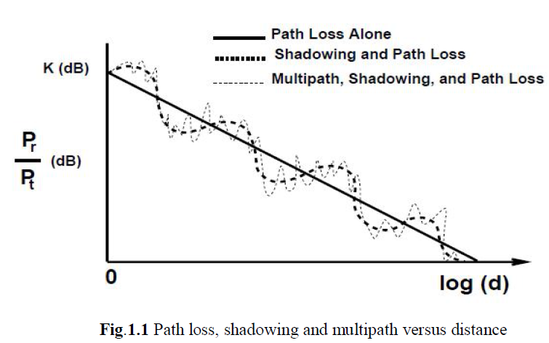

**Fig 1: Ratio of received to transmit power in dB versus log-distance**

**1. CELLULAR COMMUNICATION :-**

This system uses the concept of hand-off and frequency reuse in order to increase the coverage area and hence can accommodate a large no. of users. The basic unit of cellular communication is known s cell. It can be defined as the small geographical region which is covered by BS (Base Station). BS transmits low power signal in order to ensure that the signal is strong enough to serve a cell and does not disturbs the other neighboring cells.

**1) Frequency reuse** :- When a given area like a city is divided into small non-overlapping cells and each cell is provided with a group of frequency, then the process of selecting channel groups for all the cellular BS in cellular system is what we call as frequency planning or frequency reuse.

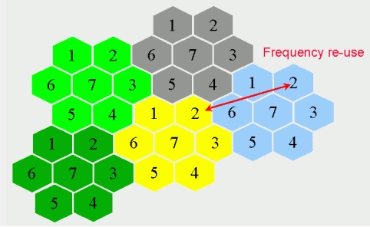

**Fig 3: Concept of Frequency Reuse**

**2) Hand-off :-** It refers to the method of changing channel related to the current connection when a call is going on. It is basically of two types :-

1. Hard hand-off :- In this, the user releases the current resource i.e Base station before getting connected to the other resource related to the cell it is entering. Here only one base station is active at a time. However this method leads to a problem known as ping pong effect. Ping-pong effect is defined as the repeated hand off between two resources because of rapid signal fluctuations. This effect can be eliminated in soft hand-offs.
2. Soft hand-off :- In this, a user can communicate with two or more BS simultaneously during the hand-off process.

**2. MULTIPLE ACCESS TECHNIQUE:-**

The technique which allows multiple users to share the allotted spectrum in the most efficient way. There are three multiple access technique based on the type of channel :-

1. **FDMA:-** In FDMA ( Frequency division multiple access) technique, a frequency band is divided into subbands and each subband is available or given for a single user access at a time. In this half of the band is used for receiving and the other half is for transmitting channel.

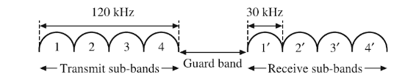

**Fig 2: Concept of FDMA**

1. **TDMA :-** In Time division multiple access (TDMA) technique, each user has access to the full band of the channel for limited duration of time.

For N users, access time=(1/N) seconds

TDMA has a better capacity than that of FDMA although it has delay problems.

1. **CDMA :-** In CDMA ( Code division multiple access) technique signals of different users are transmitted simultaneously over the same frequency band and same time period. It is basically a wide band multiple access technique. Here each user has been assigned a unique pseudo random code sequence that has a low correlation with the code sequence of other user and a strong one with itself.

In CDMA, the whole band is reused in every cell so CDMA uses the entire bandwidth for all users.

**3. GENERATIONS OF MOBILE COMMUNICATION :-**

Mobile communication is one among the fastest growing technologies in the last thirty to forty years. The Primitive first generation cellular design used analog communication based technology. It was launched by Nippon Telegraph and Telephones (NTT) of Japan in 1979 in Tokyo. This standard was based on the analog modulation where the voice signals are frequency modulated and then is transferred into the mobile network. It uses the FDMA technique and uses circuit switching method to connect devices with one another. Technologies like Nordic Mobile Telephone (NMT), Advanced Mobile Phone Service (AMPS) are some of the 1G standards. It supports only voice. It has data rate of 2.4 to 14.4 kbps and operates at a frequency of 800 MHz with a carrier frequency of 30 kHz.

The growing demand of high data rates by mobile users results in the invention of 2G. It uses digital wireless technology which allows for much better utilization of the available bandwidth. It uses TDMA and CDMA techniques and uses circuit switching for voice and Packet switching method for data communication. SMS and MMS were first introduced in 2G. Technologies like GSM (2.5G) and EDGE (2.75 G) were immerged from 2G. Data transmission capacity were increased up to 1Mbps in 2.75G. It has a Bandwidth (BW) of 25 MHz and operates at a freq. of 900 MHz, 1800 MHz and 800 MHz with carrier frequency of 200 kHz.

Third Generation (3G) introduced mobile internet access, fixed wireless Internet access, wireless voice telephony, mobile TV and video calls. It uses CDMA technique and uses packet switching method for both voice and data transmission. It has a BW of 25 MHz and operates at a freq. of 2100 MHz with carrier frequency of 5 MHz Also it has a data rate of 3.1 Mbps.

In 2009, fourth generation cellular designs were introduced which has large data transmission capability and supports services like HD mobile TV, video conferencing, live streaming, 3D TV etc. It provides 1Gbps of data rates at low mobility and 100 Mbps of data rates at high mobility. CDMA technique is used here and is totally based on packet switching. Technologies like LTE, WiMAX are some of the standards of 4G. It has a bandwidth of 100 MHz and operates at a frequency of 850 and 1800 MHz with a carrier frequency of 15 MHz.

**3.1 CALL FLOW :-**

Call flow is basically defined as a road map to how the call is handled the moment it enters the user equipment to the end of the call. Call is handled differently in different generation of cellular design like 2G(GSM), 3G and 4G.

**Second Generation :-**

A standard which is known as GSM (Global System for Mobile) communication is accepted globally in order to describe the protocols for 2G cellular system.

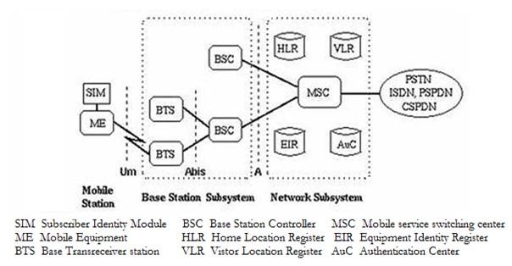

**Fig 4: Architecture of GSM**

There are four major subsystem of GSM:-

1. Mobile Station (MS) :- It is a mobile handset which consist of ME (mobile equipment) and SIM (subscriber identity module). ME has a unique identification number known as IMEI (International Mobile Equipment Identity). The SIM has also a unique Identity known as IMSI (International Mobile Subscriber Identity. SIM has algorithms for authentication check and also has subscriber related information.
2. Base Station subsystem (BSS) **:-** It performs the function related to radio frequency and consist of BTS ( Base Transceiver Station) and BSC (Base Station Controller). BTS has signal processing and control equipment radio transmitter and receiver, feeder cables and antennas which serves each cell in a network. BSC is responsible for call maintenance by controlling the power transmitted by BTS, monitoring the quality and generating a handover to another cell whenever required.
3. Network Subsystem (NSS) **:-** It is responsible for main switching functions, call processing and subscriber related functions. It consists of 5 components:-
4. MSC (Mobile Service Switching Centre) **:-** It coordinates calls to and from the GSM users.
5. HLR (Home Location Register) :-It is a basically a database to store the subscriber’s current location, subscriber information, address of the current VLR and activity status.
6. VLR (Visitor Location Register) **:-** It is a temporary database that is responsible for storing more detailed subscriber information and more current location than that of HLR.
7. EIR (Equipment Identity Register)**:-** It is used to store the list of valid mobile equipments to prevent unauthorized MS.
8. AuC (Authentication Centre) **:-** It is for authentication purpose and is integrated with HLR to keep the user ID confidential and prevents illegal attacks on the network.
9. Operation Subsystem (OSS):- It maintains the satisfactory operation of the network by minimizing the effect of faults. BSS and NSS combined to form OSS. [1]

**Third Generation (UMTS) :-**

UMTS (Universal Mobile Telecommunication System) is a 3G mobile cellular system. UMTS is basically a network which consist of 2 major elements connected over an interface known as Iu.

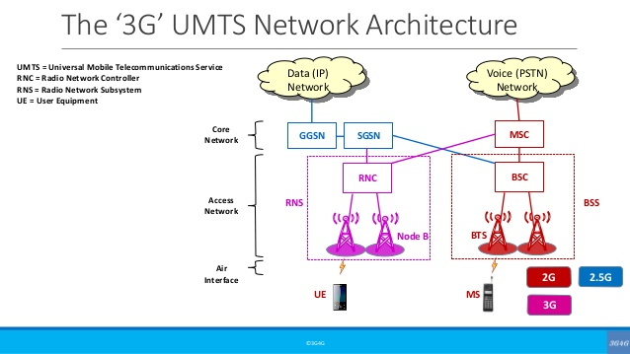

**Fig 5 : Architecture of 3G**

The two elements are :-

1. UTRAN (Universal Terrestrial Radio Access Network) **:-** It consist of Node B which is similar to the BTS of GSM architecture and RNS (Radio Network Controller) which is similar to MSC of GSM architecture. The AIR interface between user equipment and node-B is responsible for implementing RAT (Radio Access Technology) which uses W-CDMA technique to offer greater bandwidth to mobile network operators.
2. Core network **:-** It is a backbone network of 3G and it is similar to NSS of GSM architecture. The core network splits into 2 elements i.e CS (Circuit switch element) and PS (Packet switch element). CS element is responsible for voice calls and is connected to the PSTN (Public switched telephone network). PS element is responsible for data transmission and is connected to ISDN (Integrated services for digital network).

**Fourth Generation:-**

4G technology is basically an extension of 3G technology. In 4G, E-UTRAN is an evolved version of UTRAN (of 3G) and EPC (evolved packet core) is an evolved version of core network of 3G. It has high throughput and has no concept of RNC which provides high mobility. It’s architecture is simple with less no. of nodes and known as SAE (System Architecture Evolution) .

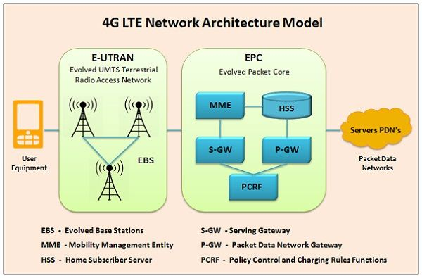

**Fig 6: Architecture of 4G**

4G architecture consists of 3 parts :-

1. UE (User equipment):- It is basically a handset that could be anything like laptop, tablet, mobile phone etc. with LTE connection.
2. E-UTRAN (evolved UTRAN) :- It establishes a radio connection between UE and EPC (Evolved Packet Core) [2]. It basically acts as a self RNC. E-UTRAN basically performs 2 functions :

* It handles low-level operations by sending commands and signaling messages.
* The digital and analog pcocessing function of its AIR interface is used to receive and transmit the radio signals to all the LTE devices.

1. EPC :- It is used to establish connection between external and internal PDN and IP multimedia subsystem. It has the following subblocks for different purposes :-
2. MME (Mobility Management Equipment) :- It is a controlling block for signaling purpose and responsible of bill generation and all. It is also responsible for tracking area updates.
3. HSS (Home Station Subsystem) :- HSS is very much similar to HLR of GSM. It keeps a permanent data base of each users.
4. S-GW (Serving Gateway):- It acts as a router to forward the data between PDN Gateway and BS.
5. P-GW (PDN Gateway) :- PDN Gateway communicates with PDN employing Interface and is responsible for packet filtering and IP address allocation.

**4. Working of towers :-**

So, before we actually connects to other user via mobile phone for voice communication, a long process takes place within seconds. Whenever an LTE system sends a signal it is captured by antenna. There are two types of Antenna :-

1. **RF antenna**:- It is responsible for radio frequency radiation, propagation and reception.
2. **Microwave antenna** :- It is responsible for microwave propagation, microwave communication, also known as backhaul communication or tower to tower communication.

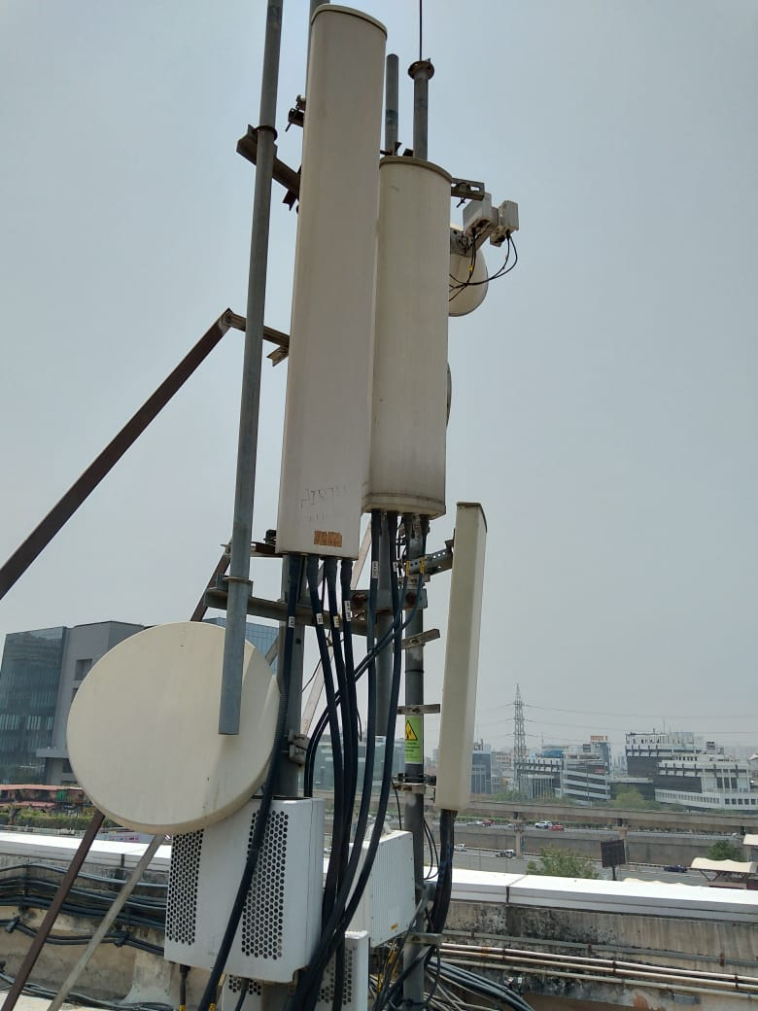

**Fig 7: Tower showing RF Antenna (Rectangular) and microwave antenna (Oval)**

Basically, there are 3 RF antennas separated at an angle of 120 degrees to receive signal from three different directions (sectors) i.e alpha, beta, and gamma. Each sector has separate RRH (Radio Remote Head) connected via jumper cables, which converts EM signals or Radio wave signals to optical signal and vice versa.

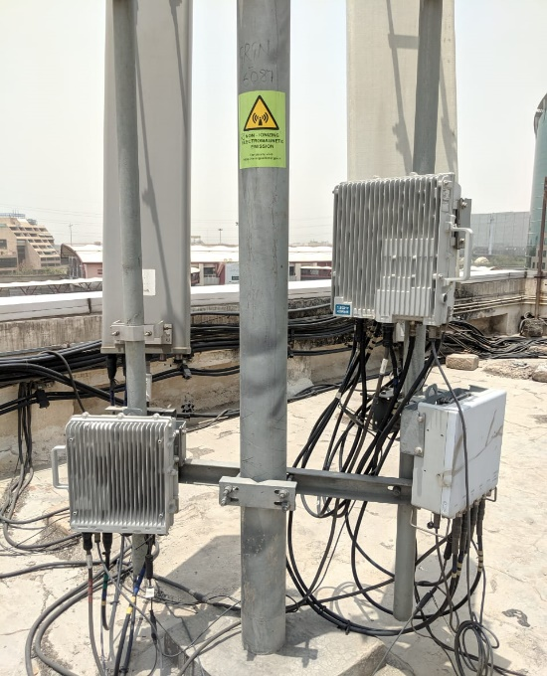

**Fig 8: Radio Remote Head (RRH)**

Functions of RRH:-

1. In the receiver part, the desired signal received from antenna is amplified and converted back to the digital signal.
2. In the Transmitter part of RRH, RF signal has been converted from digital signal and then that part of the signal is then amplified to a required power level. RF signal is then radiated in the air via antenna connected to that part.

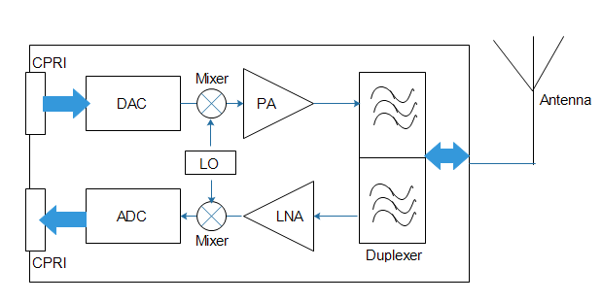

**Fig 9: Block Diagram of RRH**

After that RRH is connected to CDU (Central Digital unit) via CPRI cable (Common Public Radio Interface Cable). This CDU (or BBU) is also connected to backhaul switch and GPS antenna by particular cables.

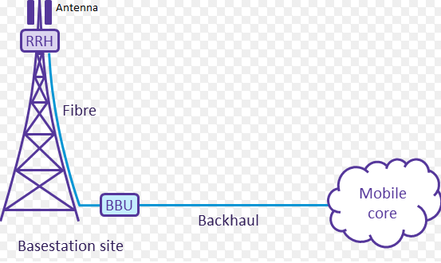

**Fig 10: RRH and CDU Connection**

The CDU is installed in the rack inside the ODC (outdoor unit) [4]. It takes its power supply from MCB (Miniature Circuit Board).

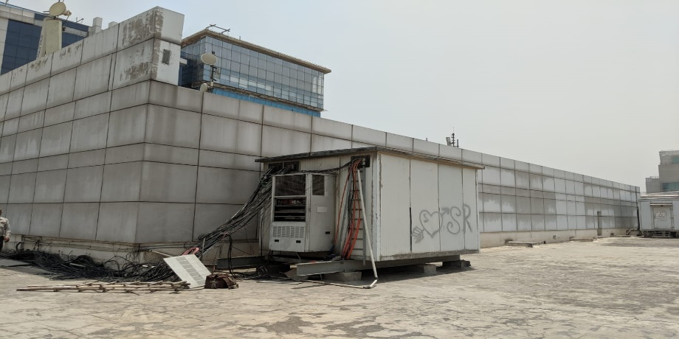

**Fig 11: Outdoor Unit (ODC)**

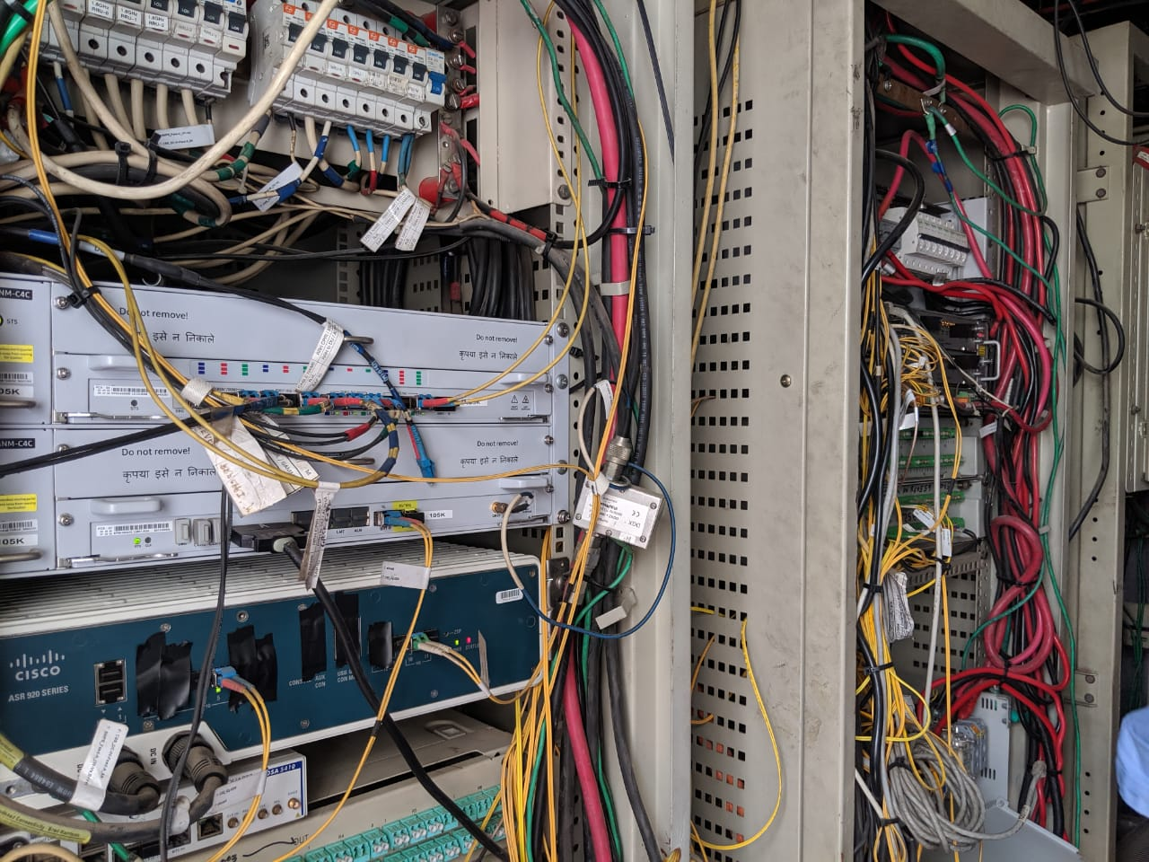

**Fig 12: Inside of ODC**

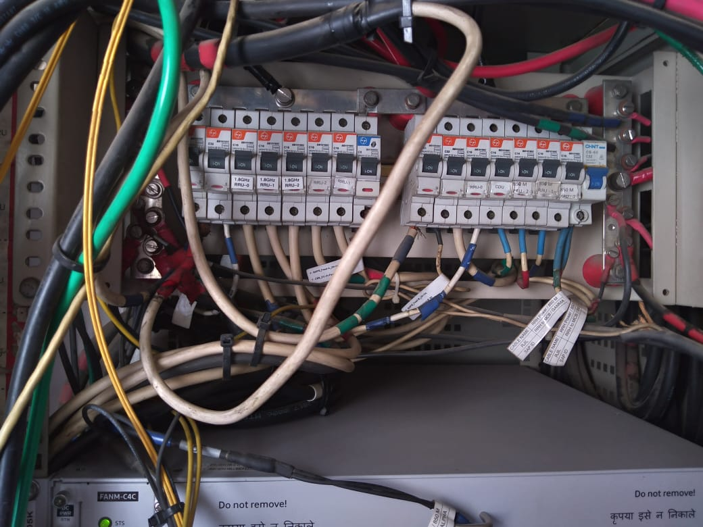 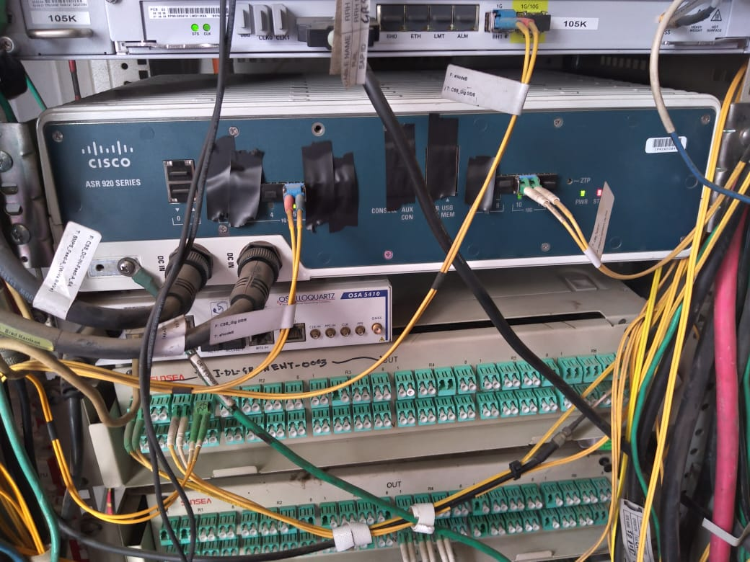

**Fig 13: Miniature Circuit Board (MCB) Fig 13: Router**

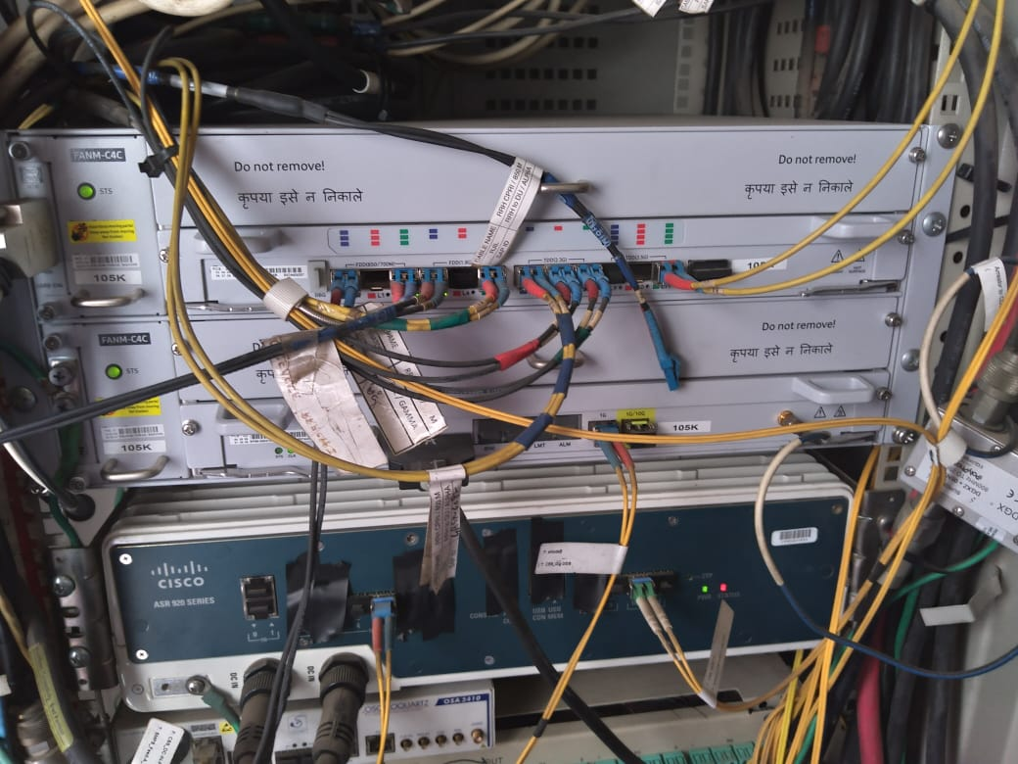

**Fig 14: CDU connected with router**

CDU has 3 series of optical fibre cable:-

* First series is of **2300 band**, for each band there are three sectors (1 colour string of each sector).
* Second series is of **1800 band**, for each band there are three sectors (2 colour string of each sector).
* Third series is of **850 band**, for each band there are three sectors (3 colour string of each sector).

NOTE :- Alpha sector is defined by blue colour, beta by red colour and gamma by green colour.

CDU performs analog to digital processing (i.e collects the traffic) and send it to the router. Router has the backhaul connection and it aggregates the signal. Different levels of aggregation routers are deployed. Each eNode B is connected via backhaul to an aggregator node, AG1. An AG2 consist of 4 rings with 5 eNode B (CSS) per ring. 10 AG1 rings connect to AG2 level. Finally AG3 supports 16 AG2 pair. The EPC are finally deployed at the AG3 level.

**5. P-GW subblock of EPC:-**

This subblock is responsible for the allocation of IP addresses. In order to Transmit any data across the network logical address or IP address is required. Only physical address is not sufficient for that. So, Internet Assigned Numbers Authority (IANA) is accountable for the allocation of physical (MAC) as well as Logical (IP) address to the users.

**Physical address :-** It is also known as Media access control address or MAC address, which is handed over to the users as well as the manufacturers of device. It is 48 bit hexadecimal address present on the NIC (Network Interface Controller) card which is a Layer 2 device.

**Logical Address :-** It’s a 32 bit IP address (IPv4) with an address space of 2^32 and is not present in the NIC card but is assigned for the purpose of routing between the networks. In order to connect over the internet IP address is required. It is generally given by Internet Service Providers (ISP). But these IP addresses are very much costly. So APNIC (Asia Pacific Network Information Centre) has divided the IP address into classes according to size.

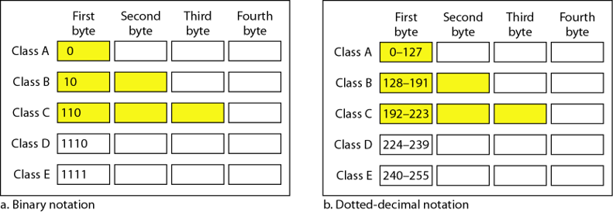

**Fig 15: Classful addressing**

Class D and E and reserved classes. Addresses in IPv4 has two parts :-

1. Host ID

2. Network ID

Class A has network ID of 8 bits and host ID of 24 bits. Class B has network ID of 16 bits and host ID of bits. Class C has network ID of 24 bits and host ID of 8 bits. So class A address is given to those which has large no. of host. However classful addresses has many demerits so they are replaced with classless addressing which provides more flexibility [5].

**Demerits of classful addressing:-**

* Millions of class A addresses remained unused.
* So many class B addresses are also wasted
* Class C addresses are not enough to fulfil the need of organization
* Multicast routing is done by class D addresses.
* For experimental purposes, class E addresses are booked.

In classful address class A,B and C has fixed subnet mask which does not provide flexibility of using less number of host in a network.

Class A 🡺 /8

Class B 🡺 /16

Class C 🡺 /24

**5.1 Classless Addressing :-**

Classless Inter Domain Routing (CIDR) provides the flexibility of reducing the number of host per network. In order to reduce the wastage of addresses, concept of subnetting is used. Subnetting is defined as a practice to divide a larger network into smaller networks or subgroups.

**Table 1 : Subnets with no. of IP addresses**

|  |  |  |
| --- | --- | --- |
| S.No. | Subnets | No. of IP addresses |
| 1 | /25 | 2^(32-25)=128 |
| 2 | /26 | 2^(32-26)=64 |
| 3 | /27 | 32 |
| 4 | /28 | 16 |
| 5 | /29 | 8 |
| 6 | /30 | 4 |
| 7 | /31 | 2 (Used in new routers with tech.  0 known as IP-subnet-zero) |
| 8 | /32 |

From the total IP provided, First and the last IP address are useless and cannot be used as Host IDs. E.g: 10.0.0.0 and 10.0.0.255 are useless (i.e 256-2=254 are used).

So, below are the usable Hosts IDs.

**Table 2: List of hosts**

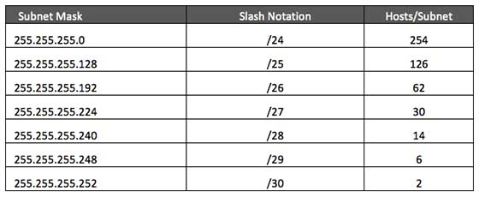

Rules of addressing in CIDR:-

1) The address used should be contiguous i.e one after the other.

2) No. of address in a block must be a power of two (i.e 0,2,4,8…)

3) The least significant bit of the first IP address should always start with zero.

**5.2 Allocation of IP addresses:-**

Allocation of IP addresses can be done manually or dynamically. So for dynamic allocation of IP addresses DHCP server is used. DHCP servers uses a pool of IP addresses and give it uniquely to the host. It also provides subnet mask, DNS servers and default gateway.

Eg.:- IP address : 192.168.1.5

Subnet mask : 255.255.255.252

Default gateway : 192.168.1.1

DNS server : 8.8.8.8

**DNS :-**

DNS stands for Domain Name System. It is a function of application layer and is used to give domain name to the IP addresses. It is used by/for programs like emails, websites etc. So, basically it is used for the mapping of IP addresses to the domain name which can be easily memorize by the users. Eg :- www.xyz.com, www.abc.co.in etc. A full domain name has labels separated by dots.

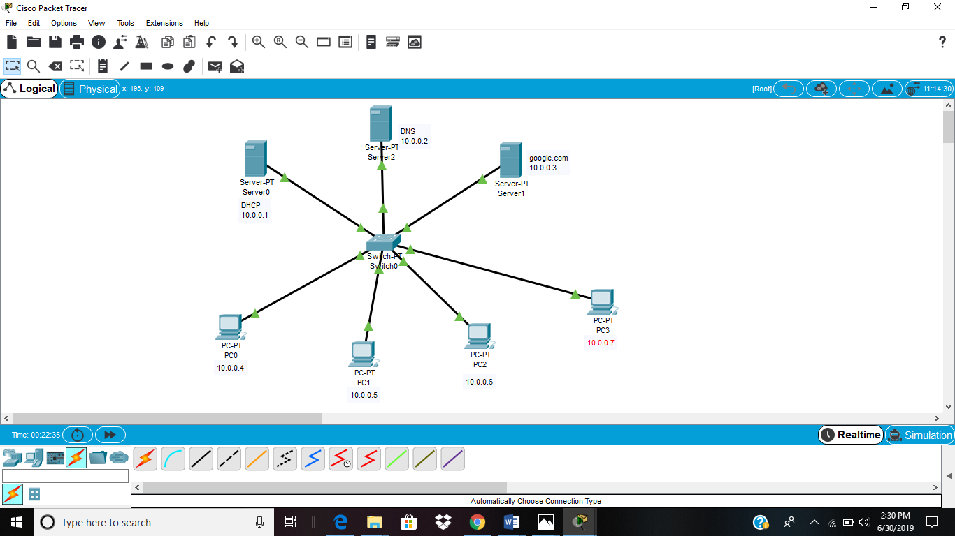

**Fig 16: Network of DNS and DHCP on packet tracer software.**

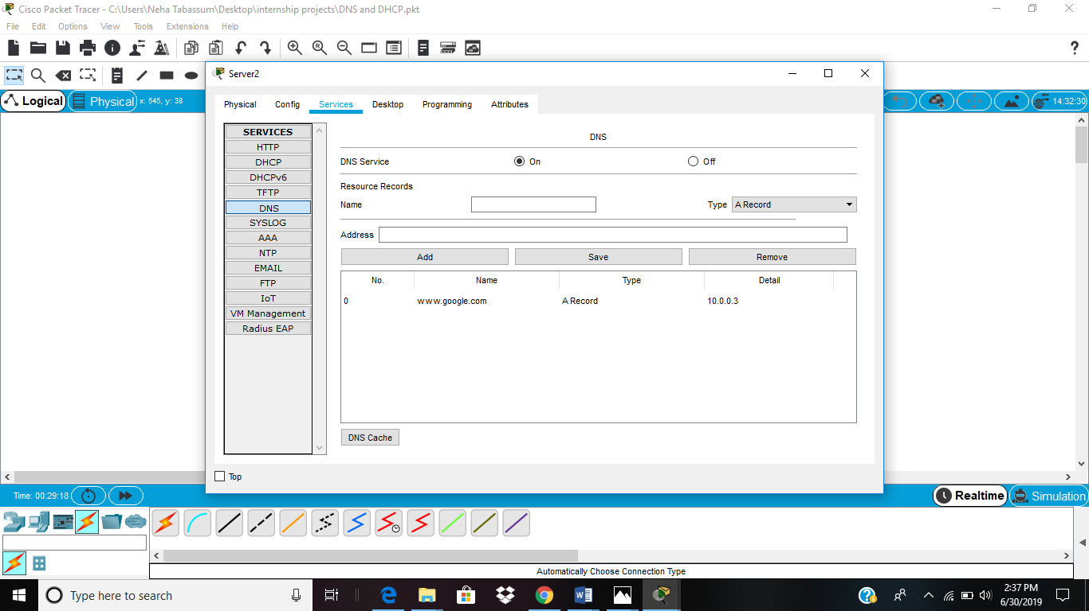

**Fig 17: Configuration of DNS**

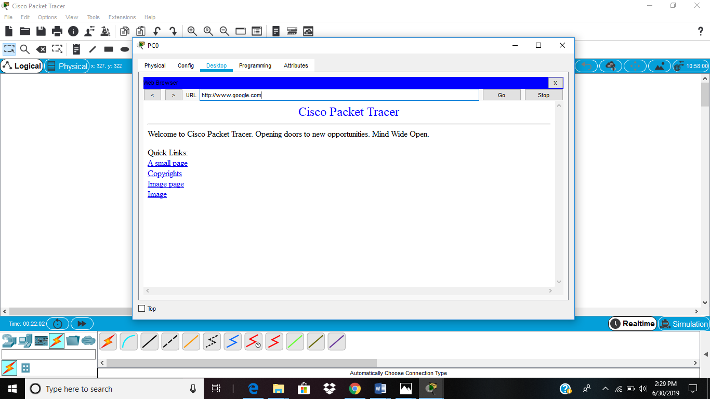

**Fig 18: Website (google.com) is accessed.**

**5.3 Reserved Addresses :-**

There are also some reserved IPv4 addresses for special purpose. These addresses cannot be used to serve the internet and are known as private addresses [6]. Below is list of private addresses:-

10.0.0.0 to 10.255.255.255…………class A

172.16.0.0 to 172.31.255.255………class B

192.168.0.0 to 192.168.255.255……class C

Also the pool of 127.0.0.0 is booked for loopback IP addressing.

In order to communicate over different networks, these addresses must be converted to the public address and the process of converting is known as NAT (Network Address Translation).

**NETWORK ADDRESS TRANSLATION :-**

With the increasing demand for IP addresses in organizations, address space of IPv4 i.e 2^32, (nearly equal to 4 billion) is not sufficient for them. So, NAT was introduced which translates the private address to public address and allow the user to communicated over the internet [6]. The organization were given private addresses and a single global address with a NAT router. NAT has a translation table with private IP address in one of the columns and a pool of global (public) IP Address in another column. Whenever a server (eg. Server A) having a private address wants to send data to the internet, it passes it to the NAT router. The router makes a note of its source address and destination address in the table and provide a global address to the packet to access the internet. When the packet returns form destination address, the router again checks its table for the source address and send the packet to the server (i.e server A).

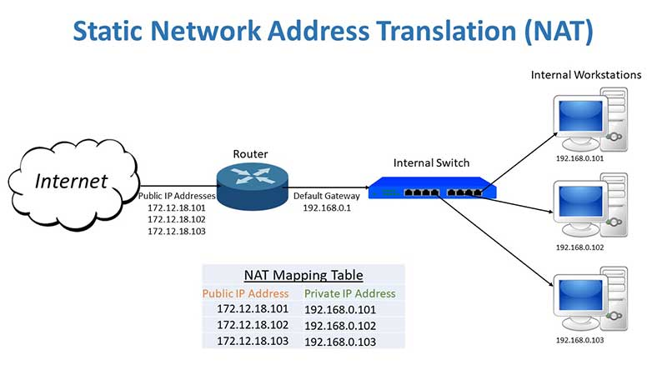

**Fig 19: Network Address Translation (NAT)**

**5.4** **IPv6 :-**

In spite of the short term solutions like classless addressing, DHCP NAT, there is still a problem of depletion of addresses. So, IPv6 came into effect. IPv6 is a 128 bit address with an address space of 2^128.

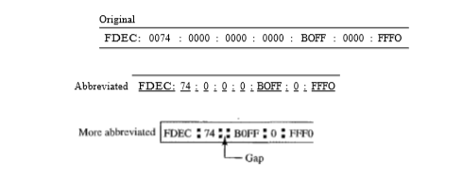

**Fig 20: Representation of IPv6 address**

There are 3 addressing methods in IPv6 representation :-

1. **Unicast address :-** When a packet is send to unicast address then that packet is delivered only to that interface which is recognized by the unicast address.
2. **Multicast address :-** When a packet is send to multicast address then it will be delivered to all the interfaces recognized by that address. This type of address is generally used by multiple host known as group.
3. **Anycast address :-** When a packet is send to anycast address then it will be delivered to only one member interface mostly the nearest one.

**6. Data (Packet) transmission over the internet :-**

Data is transmitted over the internet not in its actual form but rather they are subdivided into smaller packets and the transmission between computers (or server) across the internet is featured by TCP/IP protocol [7]. It is a five layered model consisting of physical, data link, internet (network), transport and application layer.

**Physical layer :-**

* It coordinates function required to carry a bit stream over physical layer.
* It provides physical and electrical specification for device and medium.
* It is responsible for representation of bits and synchronization of sender and receivers clock.

**Data link layer:-**

* It makes the unliable physical layer to a reliable link.
* It converts bit streams into manageable units called frames.
* It provides physical addressing to the frames and responsible for node-to-node delivery.
* It is also responsible for error control and detection of damaged, duplicate or lost frames.

**Network layer:-**

* It is responsible for host to host delivery i.e source to destination delivery of the packets across multiple networks.
* It is responsible for providing logical address and also performs the function of routing.

**Transport Layer:-**

* It is responsible for process to process delivery of the packets.
* It is also responsible for segmentation, sequencing and service-point addressing known as port address wich is used to achieve multiplexing.

**Application Layer:-**

* It is a combination of session, presentation and application layer and it enables user to access the network.
* For example :- E-mail services, file transfer etc.

Internet is a network of networks connected through routers. The packet passes through different networks and the host and the routers are identified using logical address. When the packets passes through physical layer then the host and the routers are identified using physical address. Therefore, there is a need for one to one association of logical and physical address. For this purpose ARP (Map physical address from IP address) and RARP (map IP address from physical address) is used.

Each packet that is to be send has the following information : source address, destination address, information of the source file and position of the packet. Routers are basically responsible for allowing the data packets to find the shortest or the best route between two servers that are on different network.

**6.1 Routing protocols:-**

Routing protocols defines how routers communicate with each other in order to send data packets from source to destination. Routing protocols are basically of two types:-

1. Interior gateway protocol which includes OSPF, RIP, IS-IS and EIGRP.
2. Exterior gateway protocol which includes BGP.
3. **OSPF (Open Shortest Path First)** :- This protocol will listen to the neighbors and gather all the link to develop a topology map of all the available path and save it to its database. Now from the information gathered and the topology in its database, it will calculate the shortest path to reach the subnet/network. It is basically based on the Link State Routing (LSR) Protocol.
4. **RIP (Routing Information Protocol) :-** It counts the number of hops to find the best path between the destination and the source network.
5. **IS-IS (Intermediate System to Intermediate System) :-** It is very much similar to OSPF but it supports dual IP and supports IPv6. It is basically an L2 protocol whereas OSPF is L3 protocol.
6. **EIGRP ( Enhanced Interior Gateway Routing Protocol) :-** It allows the router to exchange information in a more efficient manner. In this, the router keeps a copy of its neighbor’s routing table. If a router cannot find a route to the destination in its table then it queries it’s neighbor’s table and then their neighbor’s and so on until it finds a route. It is basically a network protocol.
7. **BGP (Border Gateway Protocol) :-** It is responsible for looking at all the available path that the data can travel and then pick up the best route, which usually means hopping between individual smaller network (autonomous system).

While sending the packets there exist a dialogue between the TCP/IP protocol of receiver and sender. If any packet goes missing then the TCP/IP protocol of the receiver side ask to resend the packet. Once all the packets reaches the destination, it is reassemble by TCP/IP of receiver to form the original data.

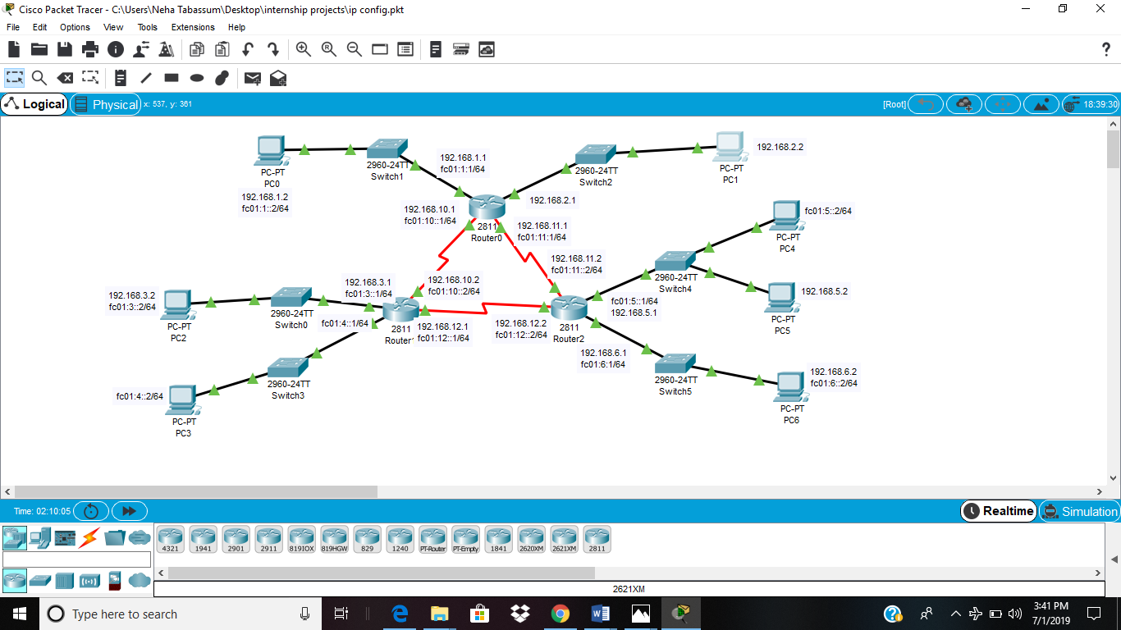

**Fig 21: Router configuration with RIP routing protocol.**

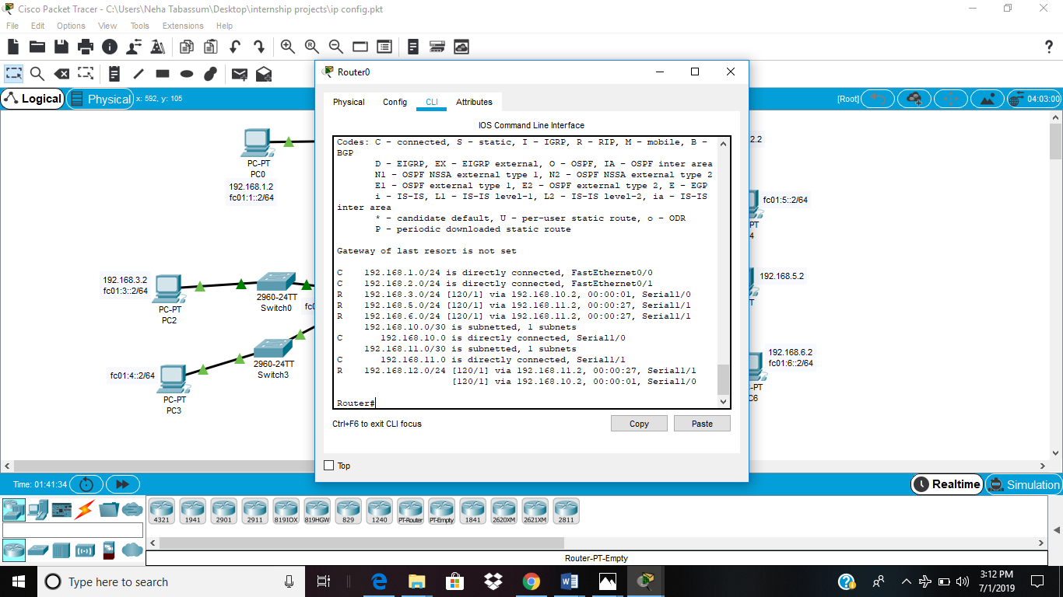

**Fig 22: IPv4 routes on router 0 (show ip route)**

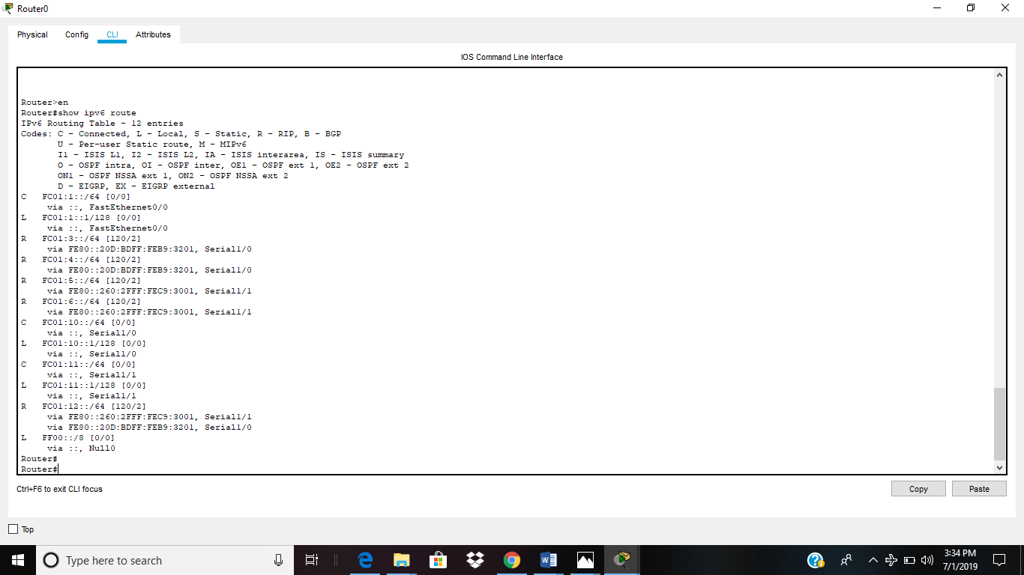

**Fig 23: IPv6 routes on router 0 (show ipv6 route)**

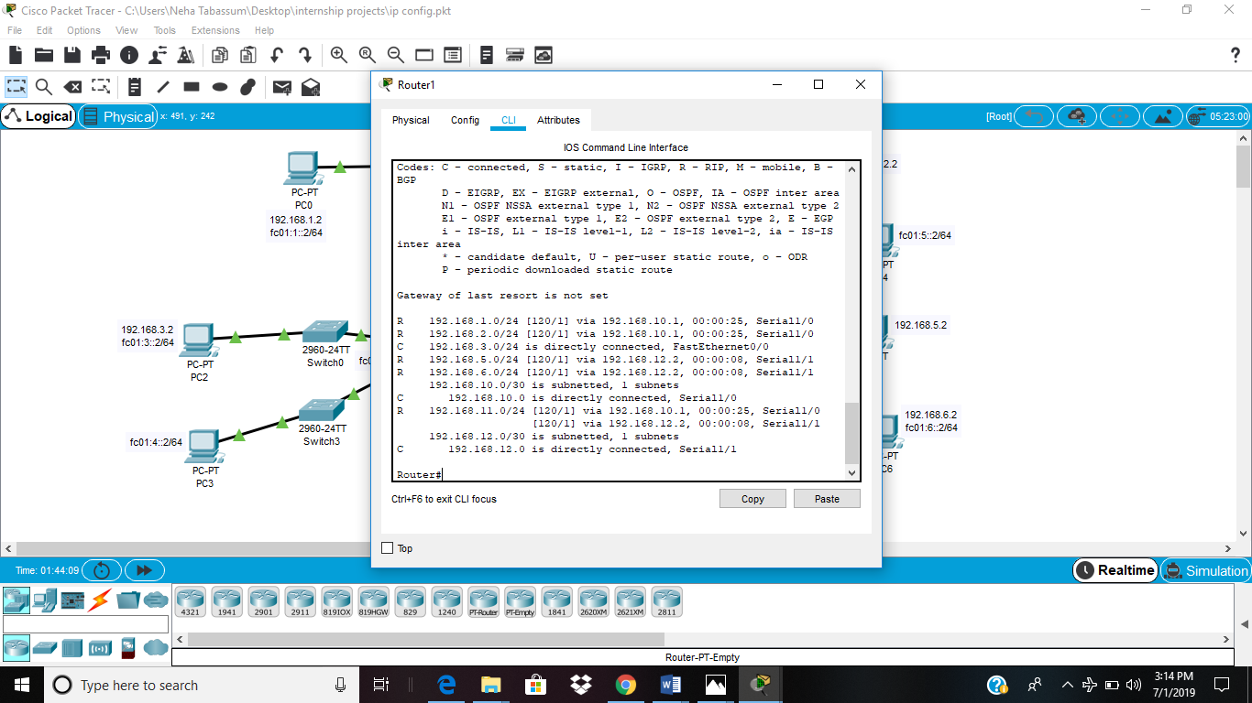

**Fig 24: IPv4 routes on router 1 (show ip route)**

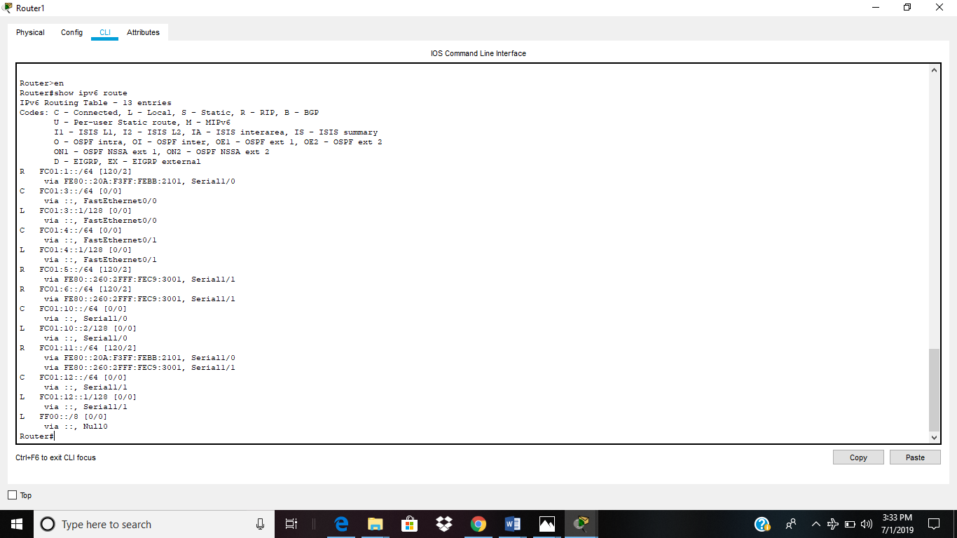

**Fig 25: IPv6 routes on router 1 (show ipv6 route)**

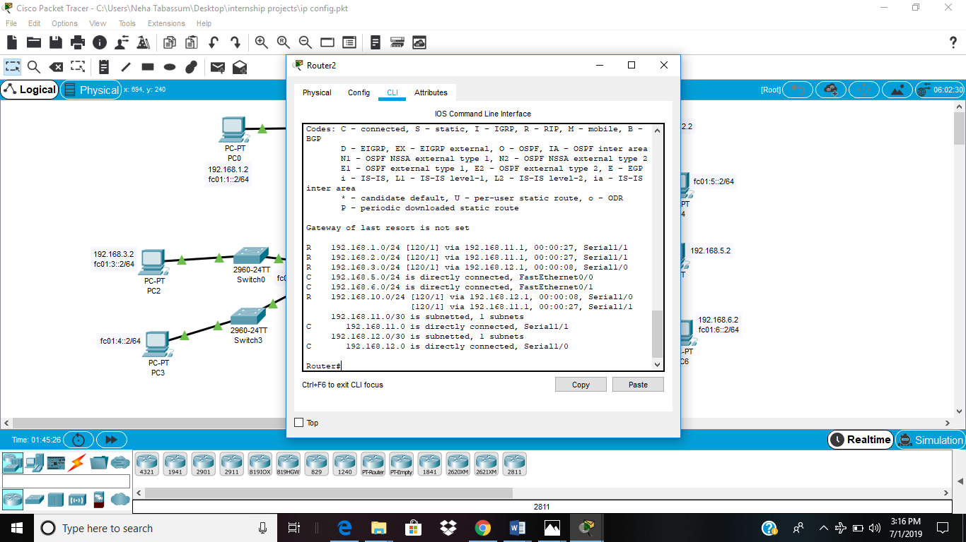

**Fig 26: IPv4 routes on router 2 (show ip route)**

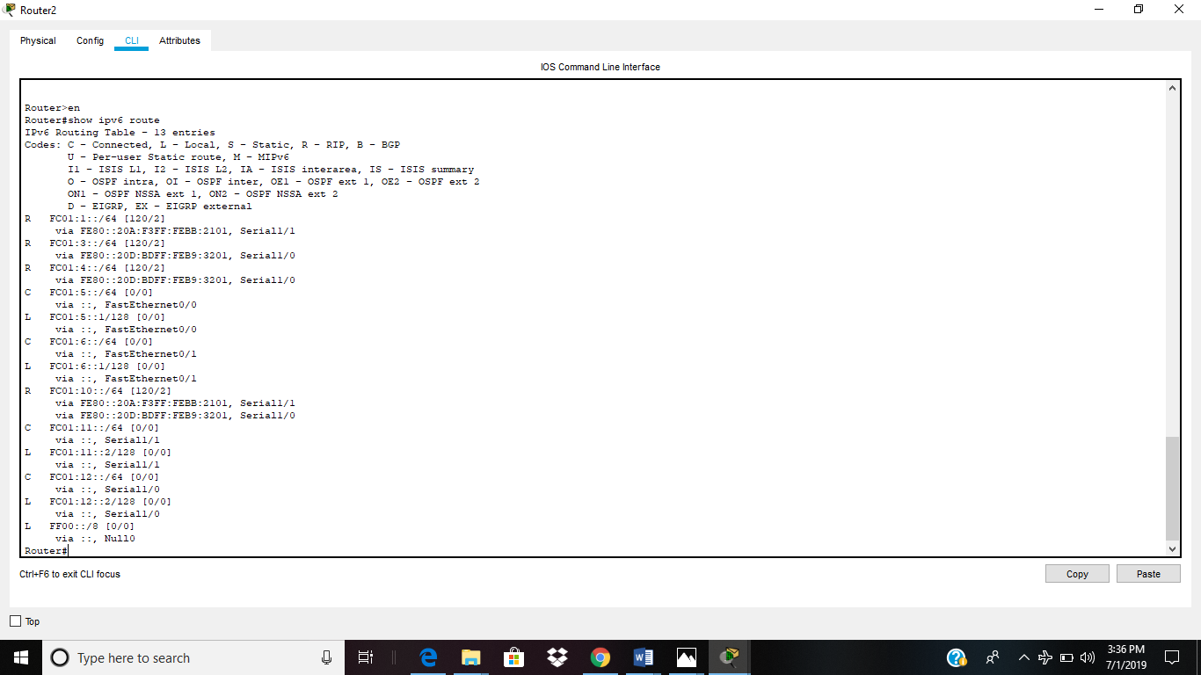

**Fig 27: IPv6 routes on router 2 (show ipv6 route)**

**Testing results :-**

To test whether a network is working properly or not, a ping command is used. Ping is a tool or a network utility program which allows you to check weather a particular host is reachable or not. Loop back address is another IP address which used to check working of the self server. Example of loop back ip address is 127.0.0.1 and it will always return a reply unless a network security system prevents it. Eg firewall.

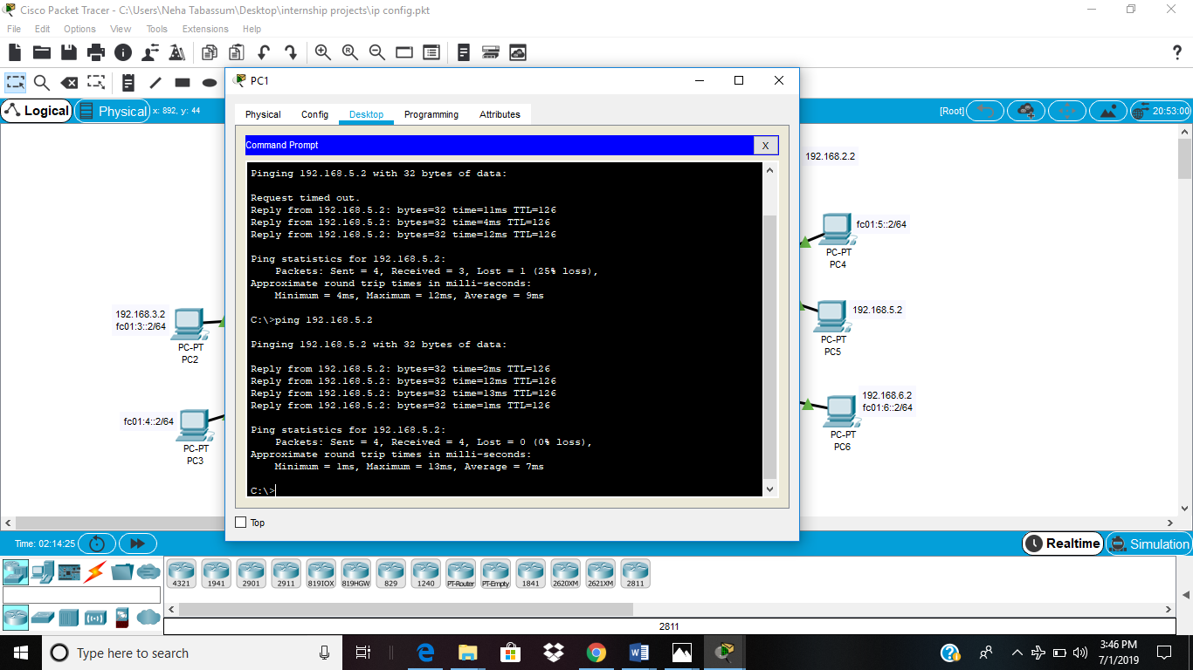

**Fig 28: Pinging from IPv4 to IPv4**

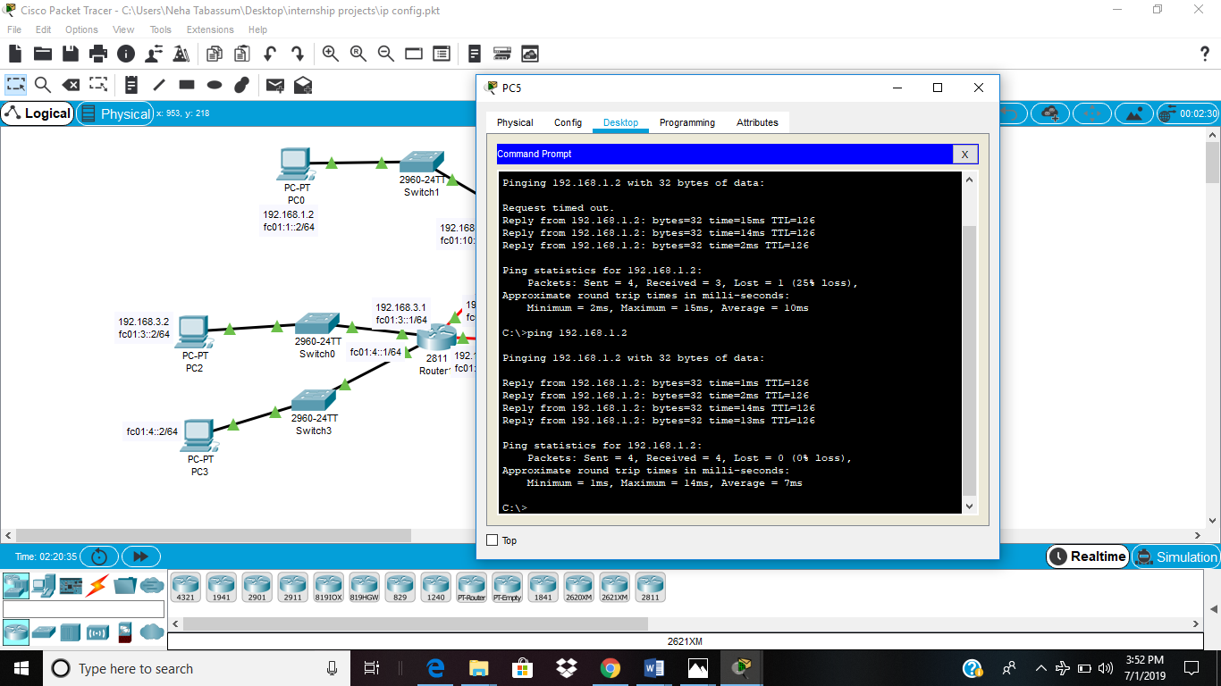

**Fig 29: Pinging from Ipv4 to IPv4 and IPv6**

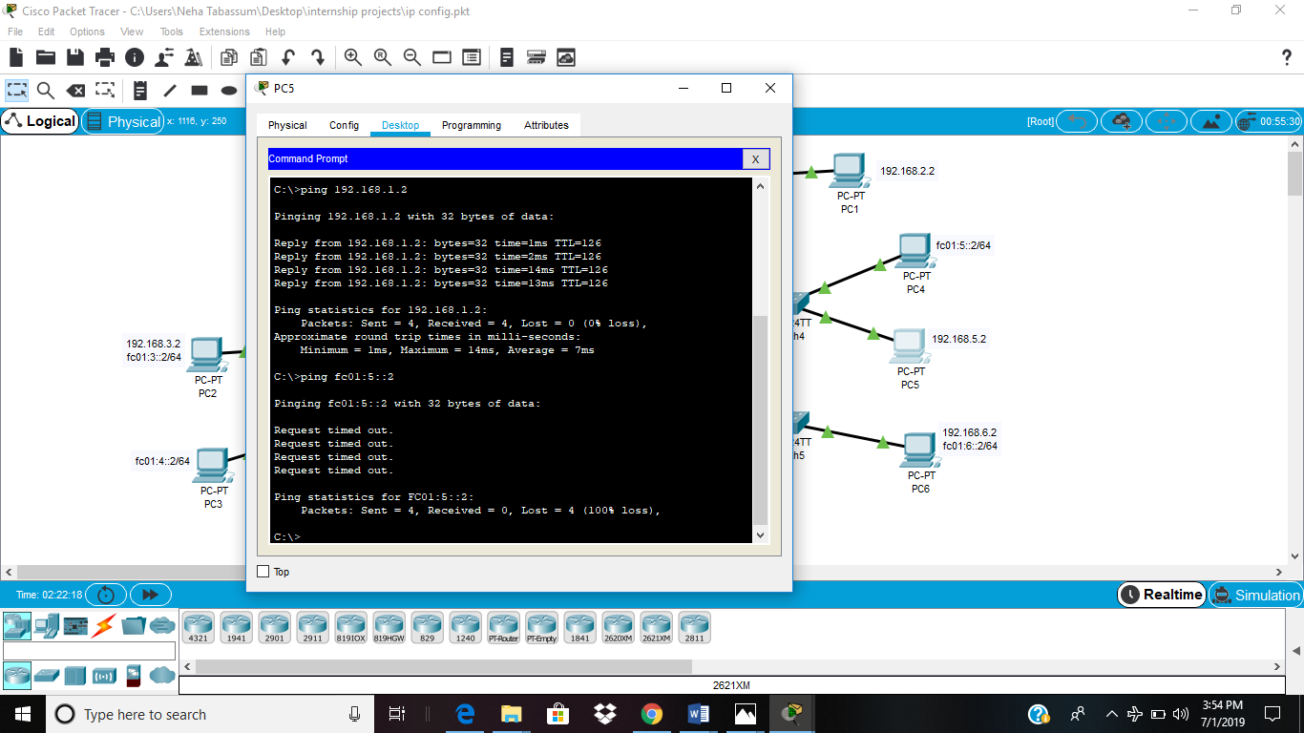

**Fig 30: Pinging from IPv4 to IPv6 (Not possible because they are on two different protocols)**

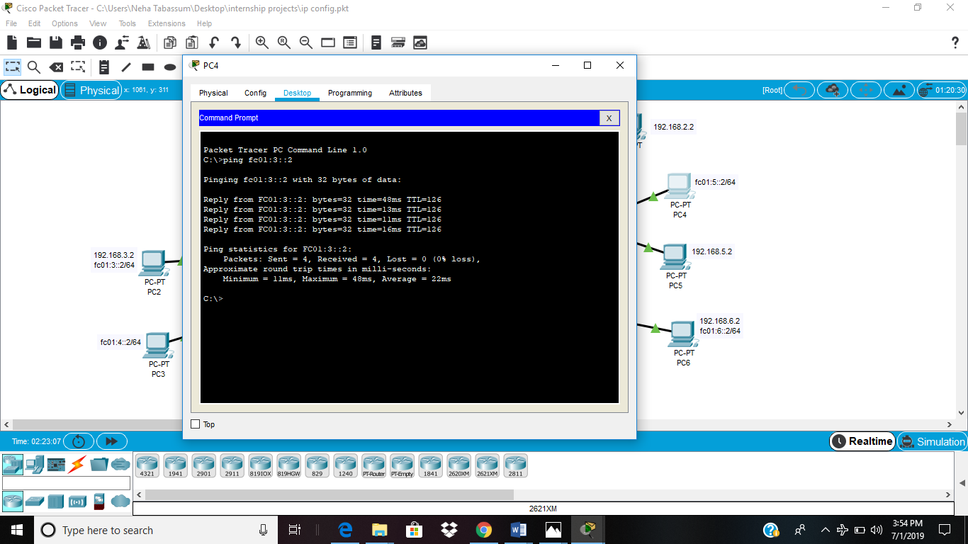

**Fig 31: Pinging from Ipv6 to IPv6**

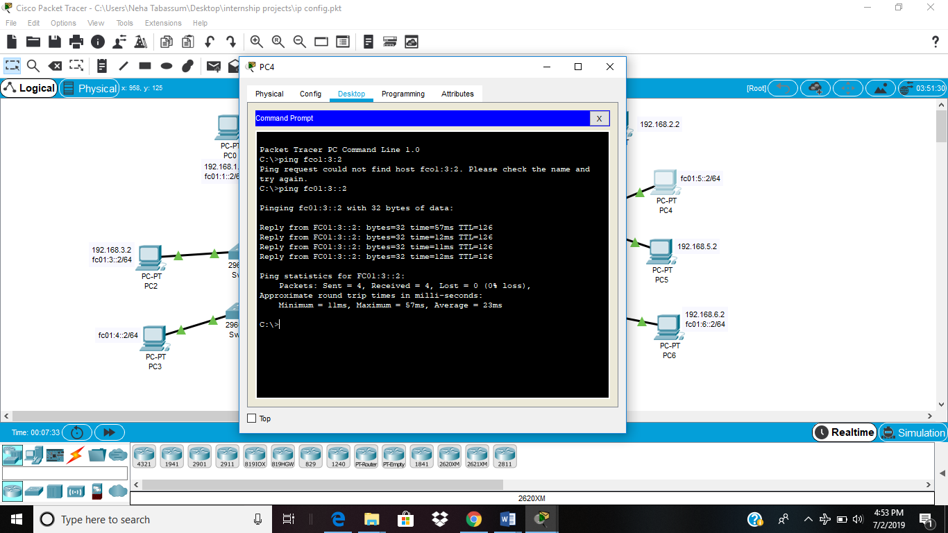

**Fig 32: Pinging from Ipv6 to IPv4 and IPv6**

* **Pinging from IPv6 to IPv4 :- Again not possible because they are on two different protocols.**

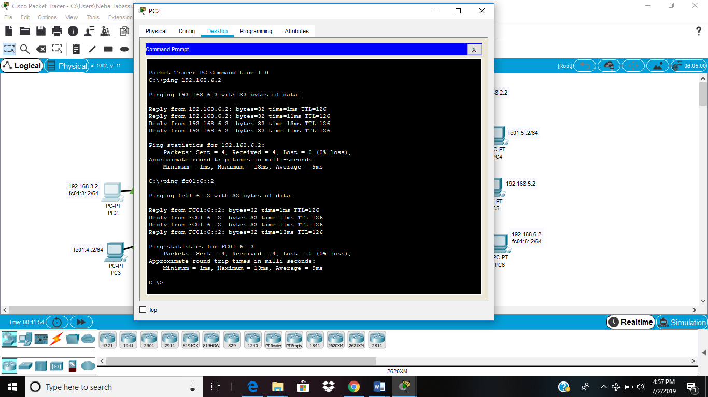

**Fig 33: Pinging from IPv4 and IPv6 to IPv4 and IPv6**

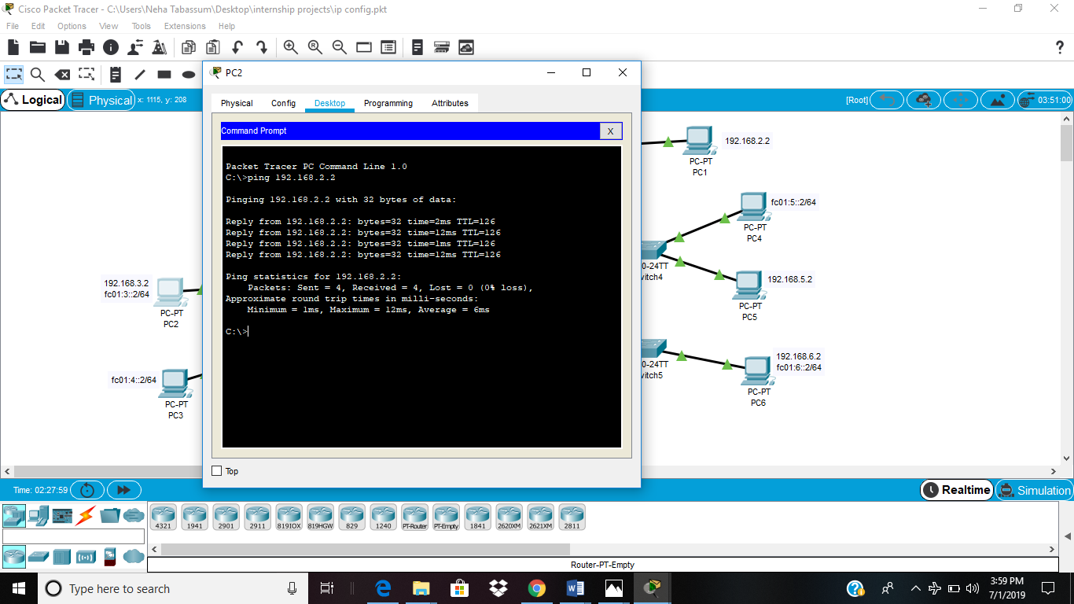

**Fig 34: Pinging from IPv4 and IPv6 to IPv4**

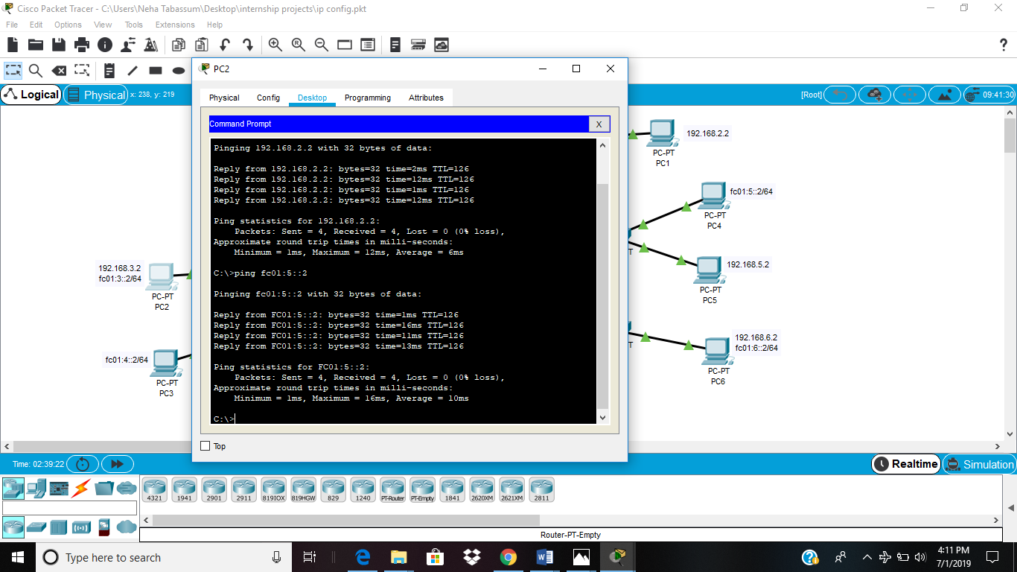

**Fig 35: Pinging from IPv4 and IPv6 to IPv6**

**7. Security:-**

In order to send the data over the internet, security is one of the major concerns now-a-days. So, firewall is used for this purpose.

**Firewall**:- It is a security system of the network which is used to monitors and controls all the outgoing and incoming network traffic depending upon the defined and advanced set of protocols. It is basically a software program which prevents illegal access to and from a private network.

A firewall usually performs the following task :

* Defend resources
* Manage and control network traffic
* Validate access
* Acts as an intermediary
* Record and report on events

Another way that allows a secure connection to another network over the internet is by establishing a VPN connection.

**VPN (Virtual Private Network) :-** It is an encrypted connection over the internet . VPN connects a laptop, PC or smartphone to another computer, somewhere over the internet and allows to browse the internet using that computer’s internet connection [8]. A VPN is formed by joining two or more VRF (Virtual Router Forwarding). So that they can share the routing table and can communicate with each other.

**8. Other tools:-**

GIS software :- Google earth

GIS stands for Geographical Information System, which is a framework for gathering, managing and analyzing data [9]. It is used to analyze spatial location using latitude and longitude (lat,long) and organizes layers of information into visualization using 3D scenes and maps.

Stages of GIS :

1. **Planning phase :-** It is an important step and provides a firm foundation of its implementation and operation. It helps to avoid any costly mistake.
2. **Survey :-** Once the planning is done then a practical survey is done to the area to see the necessary requirements.
3. **Execution :-** It is the last step of GIS implementation. It involves putting up all the requirements together and hence designing the component which will meet the users needs [10]

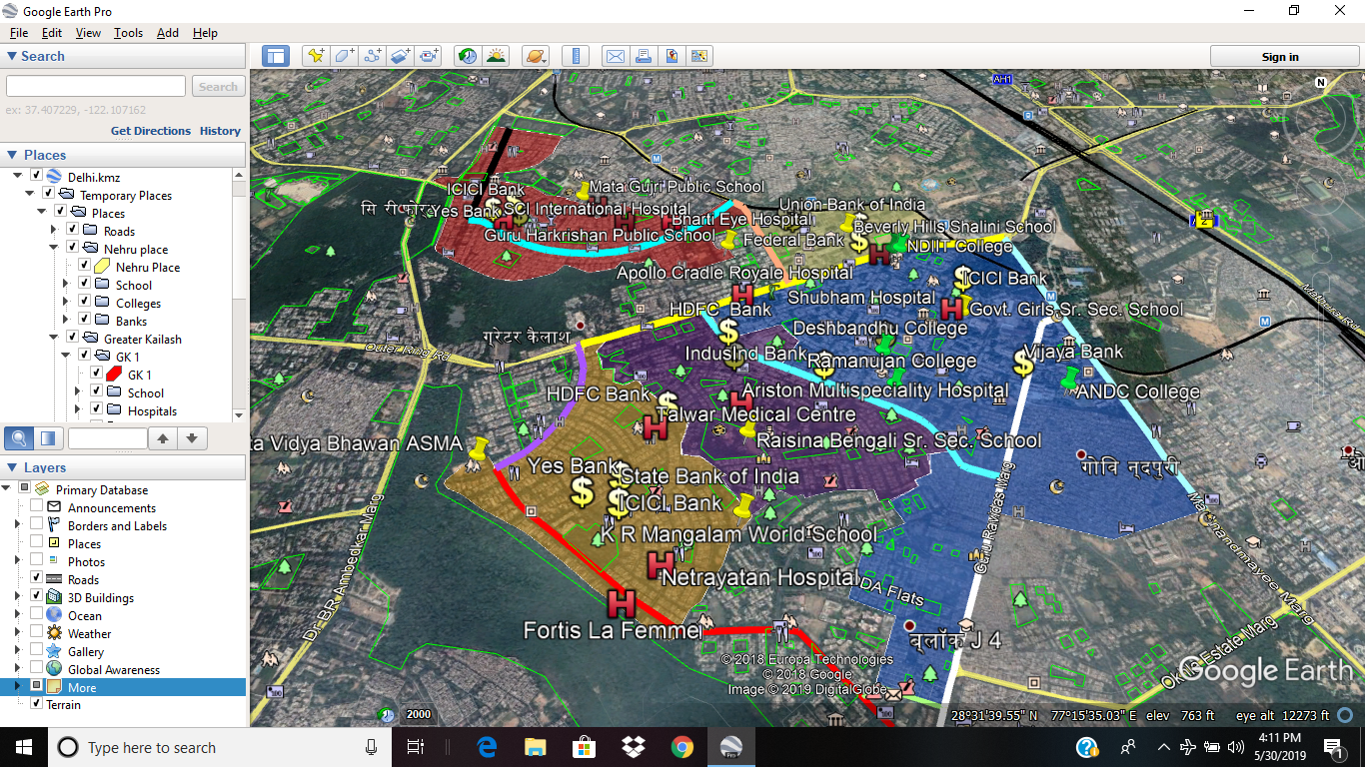

**Fig 36: Localities of South Delhi (GK, Kalkaji, Nehru Place and CR Park) with their major institutes, hospitals, banks and roads**

In GIS, functionality is basically done by the following :-

1. **Point :-** It is used to represent a particular area on a small scale eg :- schools, hospitals etc.
2. **Line :-** It is used to represent areas such as roads, bridges etc
3. **Polygon :-** It is basically used to represent a larger area like a locality, city, town etc.

So, GIS Software has a very important role in the physical implementation of project.

**Implications for future research**

With the increasing population, their needs and demand for data rates, soon 4G will be replaced by 5G. 5G is a fifth generation cellular design which will be offering more reliable connection with a greater speed to devices like smartphones, laptop etc. As 4G is offering a download speed of around 100 Mbps, 5G may be supposed to give download speed of about 1 Gbps. 5G network will be more based on the IoT (Internet of Things) Technology, making the world more connected and faster. IoT technology deals with the connection part. It can be defined as an interconnection via internet of our everyday objects which has computing devices embedded within them for sending and receiving data.

Video traffic is still a major key factor in the demand for a high speed network. Video conferencing, virtual reality and live streaming are some of the applications which are demanding higher data rates for better performance. Also the demand for such network requires a longer battery life which is also a big challenge. In order to achieve a 5G network, a lot of small cell coverage are required and also a higher bandwidth spectrum will be needed. But once 5G is implemented, it will change the whole scenario.

**Results and Conclusion**

As we have studied individual cellular designs, from voice to data transmission, we have concluded that technology has made our lives very much easy and connected. These networks has enabled businessmen to communicate worldwide in order to spread their businesses. As the purpose of communication has reached from personal level to a professional level, the evolution of 4G has provided a time saving and easy access of technology to the individuals. Earlier letters were being send and that too took 5-6 days to reach its destination, but now-a-days, e-mails can be send within few seconds and we can get the reply on the other second. All these things are possible with the evolution of internet, physical addresses, logical addresses etc.. Also with the increasing use of IPv6 addressing, concept of DNS has also increased immensely, as it is difficult for people to remember a 128 bits of address line. User has never experienced such a high value of technology. Alongside this, 5G will be having high standards that will define high capabilities which are not available in the current 5G standards.

**Annexure-1**

**Router Configuration and RIP routing protocol**

**Router 0 :-**

Continue with configuration dialog ? [yes/no] : n

Press RETURN to get started !

Router>en

Router#config t

Router (config) #interface fa0/0

Router (config-if) #ip address 192.168.1.1 255.255.255.0

Router (config-if)#ipv6 address fc01:1::1/64

Router(config-if)#no shutdown

Router (config-if)#exit

Router (config) #interface fa0/1

Router (config-if) #ip address 192.168.2.1 255.255.255.0

Router(config-if)#no shutdown

Router (config-if)#exit

Router (config) #interface se1/0

Router (config-if) #ip address 192.168.10.1 255.255.255.252

Router(config-if)#no shutdown

Router (config-if)#ipv6 address fc01:1::1/64

Router(config-if)#no shutdown

Router (config-if)#exit

Router (config) #interface se1/1

Router (config-if) #ip address 192.168.11.1 255.255.255.252

Router (config-if)#ipv6 address fc01:11::1/64

Router(config-if)#no shutdown

Routing protocol:-

IPv4:

Router (config)#do show ip int brief

Router (config)#router rip

Router (config-router)#version 2

Router (config-router)#network 192.168.1.0

Router (config-router)#network 192.168.2.0

Router (config-router)#network 192.168.10.0

Router (config-router)#network 192.168.11.0

Router#show ip route

Ipv6:

Router>en

Router#config t

Router(config)#ipv6 unicast-routing

Router (config)#ipv6 router rip ip6

Router (config-rtr)#int fa0/0

Router (config-if)#ipv6 rip ip6 enable

Router (config-if)#int fa0/1

Router (config-if)#ipv6 rip ip6 enable

Router (config-if)#int se1/0

Router (config-if)#ipv6 rip ip6 enable

Router (config-if)#int se1/1

Router (config-if)#ipv6 rip ip6 enable

Router (config-if)#exit

Router(config)#exit

Router#show ipv6 route

**Router 1:-**

Continue with configuration dialog ? [yes/no] : n

Press RETURN to get started !

Router>en

Router#config t

Router (config) #interface fa0/0

Router (config-if) #ip address 192.168.3.1 255.255.255.0

Router (config-if)#ipv6 address fc01:3::1/64

Router(config-if)#no shutdown

Router (config-if)#exit

Router (config) #interface fa0/1

Router (config-if)#ipv6 address fc01:4::1/64

Router(config-if)#no shutdown

Router (config-if)#exit

Router (config) #interface se1/0

Router (config-if) #ip address 192.168.10.2 255.255.255.252

Router (config-if)#ipv6 address fc01:10::2/64

Router(config-if)#no shutdown

Router (config-if)#exit

Router (config) #interface se1/1

Router (config-if) #ip address 192.168.12.1 255.255.255.252

Router (config-if)#ipv6 address fc01:12::1/64

Router(config-if)#no shutdown

Router (config-if)#exit

Routing protocol:

IPv4:

Router (config)#do show ip int brief

Router (config)#router rip

Router (config-router)#version 2

Router (config-router)#network 192.168.3.0

Router (config-router)#network 192.168.10.0

Router (config-router)#network 192.168.12.0

Router#show ip route

Ipv6 :

Router>en

Router#config t

Router(config)#ipv6 unicast-routing

Router (config)#ipv6 router rip ip6

Router (config-rtr)#int fa0/0

Router (config-if)#ipv6 rip ip6 enable

Router (config-if)#int fa0/1

Router (config-if)#ipv6 rip ip6 enable

Router (config-if)#int se1/0

Router (config-if)#ipv6 rip ip6 enable

Router (config-if)#int se1/1

Router (config-if)#ipv6 rip ip6 enable

Router (config-if)#exit

Router(config)#exit

Router#show ipv6 route

**Router 2:-**

Continue with configuration dialog ? [yes/no] : n

Press RETURN to get started !

Router>en

Router#config t

Router (config) #interface fa0/0

Router (config-if)#ipv6 address fc01:5::1/64

Router(config-if)#no shutdown

Router (config-if) #ip address 192.168.5.1 255.255.255.0

Router(config-if)#no shutdown

Router (config-if)#exit

Router (config) #interface fa0/1

Router (config-if) #ip address 192.168.6.1 255.255.255.0

Router (config-if)#ipv6 address fc01:6::1/64

Router(config-if)#no shutdown

Router (config-if)#exit

Router (config) #interface se1/1

Router (config-if) #ip address 192.168.11.2 255.255.255.252

Router (config-if)#ipv6 address fc01:11::2/64

Router(config-if)#no shutdown

Router (config-if)#exit

Router (config) #interface se1/0

Router (config-if) #ip address 192.168.12.2 255.255.255.252

Router (config-if)#ipv6 address fc01:12::2/64

Router(config-if)#no shutdown

Router (config-if)#exit

Routing protocol:

IPv4:

Router (config)#do show ip int brief

Router (config)#router rip

Router (config-router)#version 2

Router (config-router)#network 192.168.5.0

Router (config-router)#network 192.168.6.0

Router (config-router)#network 192.168.11.0

Router (config-router)#network 192.168.12.0

Router#show ip route

Ipv6 :

Router>en

Router#config t

Router(config)#ipv6 unicast-routing

Router (config)#ipv6 router rip ip6

Router (config-rtr)#int fa0/0

Router (config-if)#ipv6 rip ip6 enable

Router (config-if)#int fa0/1

Router (config-if)#ipv6 rip ip6 enable

Router (config-if)#int se1/0

Router (config-if)#ipv6 rip ip6 enable

Router (config-if)#int se1/1

Router (config-if)#ipv6 rip ip6 enable

Router (config-if)#exit

Router(config)#exit

Router#show ipv6 route

**References**

[1] Thiagarajan Viswanathan, Manav Bhatnagar. n.d. Telecommunication Switching Systems and Networks, Second Edition.

[2] LTE technology overview, prepared by samsung, approved by RJIL,

https://www.slideshare.net/maheshsavita/day-1-lte-technology-overview

[3] http://www.techplayon.com/rrh-remote-radio-head-connected-bbu-base-band-unit/

[4] Reliance Jio Telecom, LTE System Overview for Reliance Jio Installation Project, 2 January,2017,http://reliance-jio-telecom.blogspot.com/2017/01/lte-system-overview-for-reliance-jio.html

[5] Andrew S. Tanenbaum, David Wetherall. n.d. Computer Networks.Pearson, 23-Jul-2013.

[6] Behrouz A. Forouzan, Sophia Chung Fegan. n.d. Data Communications and Networking, Fourth Edition. mcgraw hill education.

[7] Internet and Networks, http://www.cellbiol.com/bioinformatics_web_development/chapter-1-internet-networks-and-tcp-ip/data-transmission-on-the-internet/

[8] Express VPN, https://www.expressvpn.com/internet-privacy/guides/vpn-security-work/

[9] https://serc.carleton.edu/introgeo/google_earth/what.html

[10] ADVANCED GEOGRAPHIC INFORMATION SYSTEMS – Vol. II - GIS Project Planning and Implementation – Somers R.M., Somers-St. Claire, Fairfax, Virginia, USA